Volunteer Handbook
Welcome! Thank you for your interest in volunteering at Ballard Center. One of the most important roles as a volunteer is understanding the services we provide. To get started, please review the information in this handbook to learn about what we do at Ballard Center and how your volunteering makes a difference in the community.
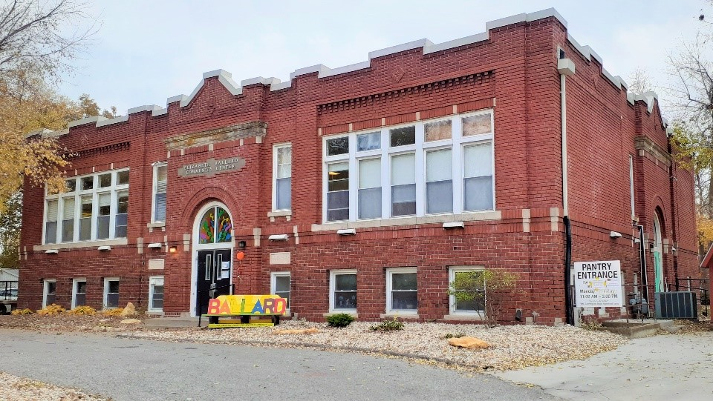
Our Mission:
Ballard Community Center partners with families to achieve stability through early childhood education and needs-based services.
Our Vision:
Since 1965, Ballard Center has served an important role in our community by offering safety-net support services, which includes emergency services to families to promote stability, and quality early childhood education at an affordable price. These services strengthen families and create lasting change. We believe that the first step in changing lives is to acknowledge that the disparities brought about through poverty exist and strive to address the barriers our children and clients face in finding safety and support.
Contact volunteers@ballardcenter.org or call (785) 842-0729 with any questions/concerns.

Ballard Community Center Hours:  Monday-Friday: currently, visitors by appt only  Saturday and Sunday: CLOSED | Website: ballardcenter.org  Phone Number: 785-842-0729
Pantry Hours:  Monday-Friday: currently by appt only  Saturday and Sunday: CLOSED | Ballard Center Address:  708 Elm St.  Lawrence, KS 66044

About Ballard Center
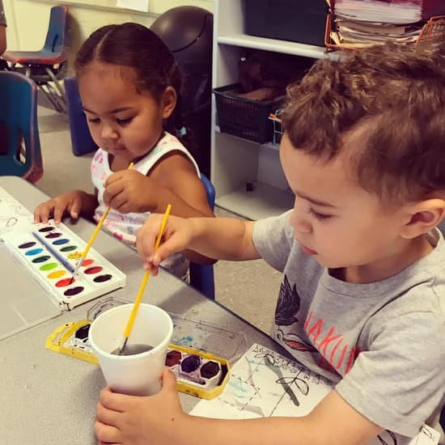
Early Childhood Education Program
At Ballard Center we provide an affordable, high quality early childhood education program for children ages 2-5. Our program supports a developmentally focused, age-appropriate learning environment to promote both educational and family-based growth.
Ballard Center also offers a family connections program and on-site counseling to support the structure, engagement, and relationships of families.
Family Stabilization and Basic Life Assistance
At Ballard Center we recognize the need for community-based services and assistance. Here are some of the main services we provide to low-income individuals and families:
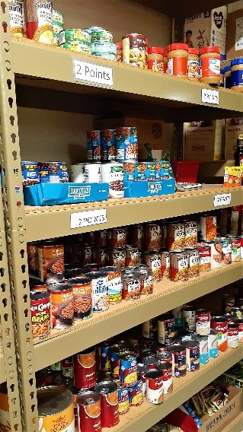
Clothing Pantry: Access to free clothing year-round for adults and children of all ages. Job-specific apparel available.
Food and Household Goods Pantry: Access to a range of food and household items including diapers, personal care items, and other home essentials.
Mobile Food Pantry: A partnership with Harvesters offered twice a month at the Douglas County Fairgrounds.
Rent and Utility Assistance: Financial Assistance to families with utility shutoff or eviction notices.
Resource Referrals: Referrals to other community agency partners who may be able to assist with services we are unable to provide.
Seasonal Events: Participation or hosting of community service-based events such as the Holiday Bureau, Warm Hearts, Changing Lives Gala, and Rev It Up car show.
Volunteer Roles and Responsibilities
The time and support contributed from volunteers enables the growth and existence of Ballard Center.
Since the opening of Ballard, volunteers have played a significant role in the success and advocacy of the organization. The commitment of volunteers allows for an extension of services and resources to promote our mission and passion of serving the community.

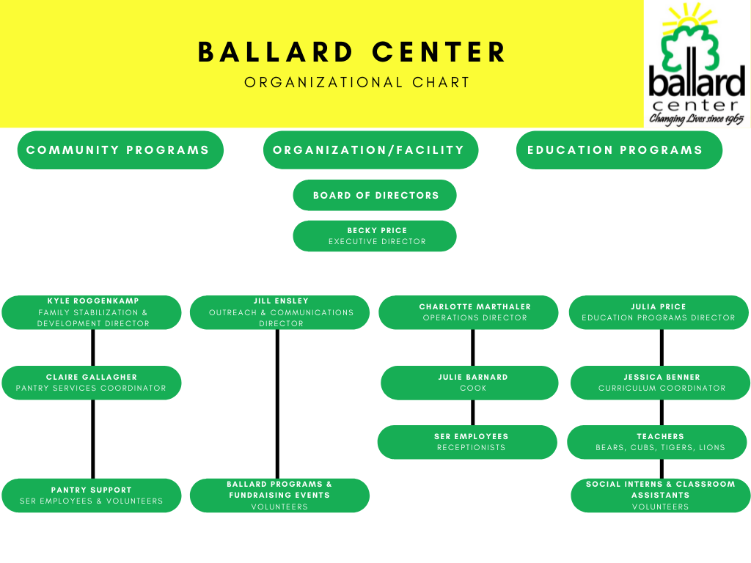
Volunteer responsibilities will vary depending on the task given. Volunteers will be placed in a position that suits their interests as well as Ballard Center needs. Our volunteer positions include: pantry support, classroom/playground support, fundraising, events, and more.
As a general rule, we ask that all volunteers come to Ballard with a positive attitude and welcoming demeanor. The Ballard Center is committed to providing an inclusive and safe environment for all people, especially the children attending our school. Regardless of the volunteer task, we ask that all volunteers represent Ballard by remaining respectful and courteous when interacting with others and performing duties.

Volunteer Policies and Procedures
Ballard Center, like most nonprofit organizations, depends on the good will and charitable contributions of the public to exist and thrive. These establishments do not generate revenue to support themselves, and therefore depend on help from the community at large to offer the programs and services they have provided in years past. At Ballard, child safety remains our number one priority. Below is a list of guidelines that must be adhered to by volunteers working in Ballard Center.
*Please note: all volunteers must be at least 16 years of age, unless accompanied by an adult.
Requirements:
- Complete the volunteer interest form.
- Sign a confidentiality agreement.
  - Volunteers must follow the guidelines that information about children, families, and clients is treated as confidential and must not be discussed outside of Ballard.
- Sign in and out upon entering/exiting the building at the front desk or pantry.
- Wear identification badges when they are in the Ballard Center (located by sign in/out sheet).
- Volunteers should park in the parking lot on the south side of the building.
- Complete volunteer feedback survey at scheduled intervals.
- Read and adhere to the volunteer policies and procedures as outlined in this document.
- COVID-19 response: all volunteers must wear a mask and use sanitization products, unless proof of vaccination is shown to the Volunteer Coordinator or another staff member.
Code of Conduct:
- Volunteers should be respectful of all staff and clients they interact with, and communicate any issues or questions they have with the Volunteer Coordinator.
- At all times Ballard volunteers should be aware of how their actions appear to community members and families served through the Ballard Center.
- As a trauma-informed organization we are committed to conducting ourselves in a manner that reduces barriers to services and does not retraumatize those seeking services and support.
- Discrimination/harassment is strictly prohibited and will result in a dismissal of the volunteer.

Disclaimer: Photos might be taken of service activities to use for social media and the website. If you would not like to be photographed, please email the Volunteer Coordinator.

Safety Procedures
FIRE
Cubs Classroom, Lions Classroom, Administration Staff and Education Office Staff will exit through the front door, utilize sidewalks to walk around the building, and meet in the Parking Lot in front of John Taylor Park.
Bears Classroom, Tigers Classroom and any additional visitors or volunteers will exit through the north door in the Bears Classroom, exit playground through north gate, utilize sidewalks to walk around the building, and meet in the Parking Lot in front of John Taylor Park.
Pantry Staff, Volunteers, and Clients will exit through the pantry entrance, utilize sidewalls to walk around the building, and meet in the Parking Lot in front of John Taylor Park.
TORNADO
Cubs Classroom, Lions Classroom, and Education Office Staff, and any additional visitors or volunteers will immediately proceed to the Northwest Basement Restroom.
Bears Classroom, Tigers Classroom, Administration Staff, Pantry Staff/Volunteers/Clients will immediately proceed to the Northeast Basement Bathroom.
FLOOD
All students, staff, volunteers, visitors, and clients will proceed to the 2nd Floor Conference Room and evacuate as necessary with the assistance of emergency personnel.
SERIOUS INJURY OR ILLNESS
Education Staff and Students: Notify Education Office Staff immediately of the type and extent of injury or illness. Education Office Staff will immediately contact the parent/guardian or emergency contact, and 911 if necessary. If Education Office Staff are unavailable, the Lead Teacher in the Classroom will immediately contact the parent/guardian or emergency contact, and 911 if necessary. Education Office Staff and Teaching Staff will assist in removing and supervising of the remainder of the class in another safe area.
All other Staff, Volunteers, Visitors/Pantry Clients: Notify Administration Office staff immediately of the type and extent of injury or illness. Administration Office Staff will immediately contact the listed emergency contact, and 911 if necessary.
POISON CONTROL: 1-800-332-6633
CIVIL DISORDER
Immediately notify Administration staff. Office staff will contact emergency personnel. If Administration Staff are unavailable, the Lead Teacher in the classroom will contact emergency personnel. In the case of a telephone outage, the Lead Teacher in the Cubs Classroom will proceed to the Central Alarm Panel located in the upstairs landing outside the Administration office and push the Emergency Alarm button. This will dispatch law enforcement immediately.

